Crate one Jar file with two Angular

- Create Angular run file
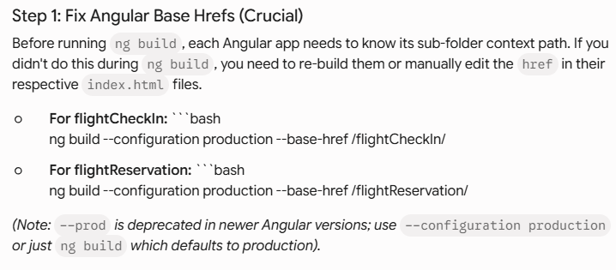

>>ng build --configuration production --base-href /flightCheckIn/
>> ng build --configuration production --base-href /flightReservation/

This is like the end point url that we can access to this two Angular

- Copy the run file from Angular to the static in the Spring Boot project
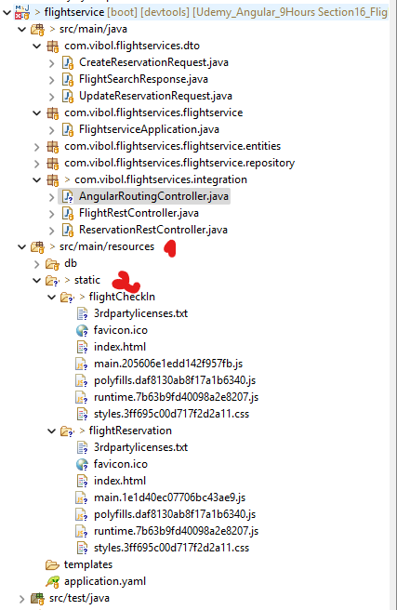

3- Add controller in the spring boot

package com.vibol.flightservices.integration;

import org.springframework.stereotype.Controller;
import org.springframework.web.bind.annotation.GetMapping;

@Controller
public class AngularRoutingController {

@GetMapping(value = {
"/flightCheckIn",
"/flightCheckIn/",
"/flightCheckIn/{path:[^\\.]*}"
})
public String forwardCheckIn() {
return "forward:/flightCheckIn/index.html";
}

@GetMapping(value = {
"/flightReservation",
"/flightReservation/",
"/flightReservation/{path:[^\\.]*}"
})
public String forwardReservation() {
return "forward:/flightReservation/index.html";
}
}
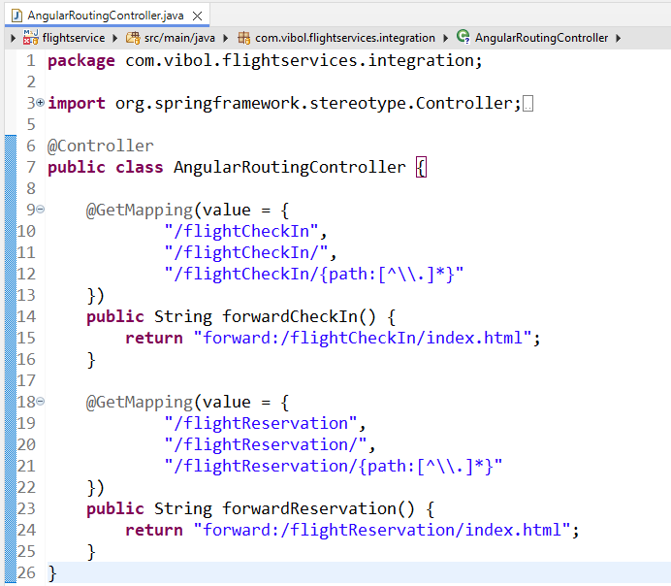

Create Jar file:

>> mvn clean package

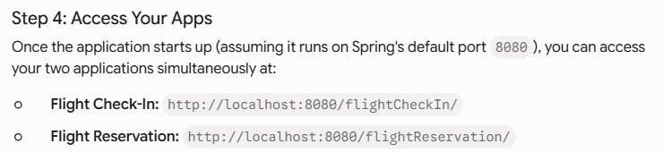

Note Error:

Because the spring boot does not scanner the controller from the app stat we need to verify again!
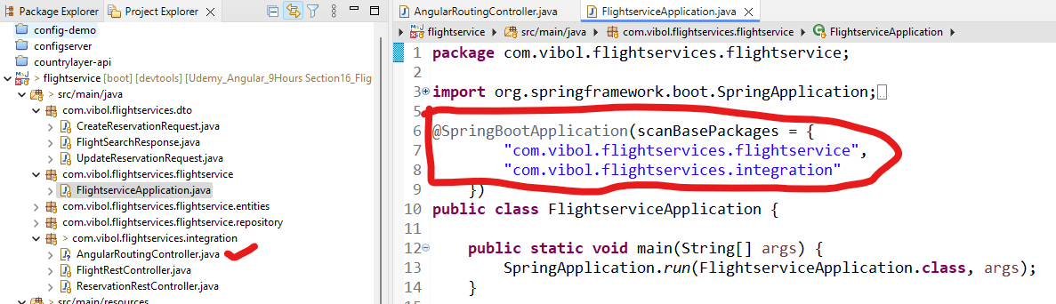

Note:
If we have only one Angular one, we do not need to create controller. Just copy the run file from angular to static.

